**MATILLION - SECURITY MONITORING DASHBOARD**

Matillion security monitoring dashboard is used to track user configuration data, Audit logs, Permission groups of the users. Analysis of security-related Audit logs can help to identify violations of security policies and potential threats to an organization's security. Analysis of users assigned to different Permission groups can help organizations to more efficiently assign appropriate privileges.

**Create Tables in Snowflake To Store Matillion Security/User Related Data:**

USE ROLE MATILLION_MONITOR_ADMIN;

//-------------AUDIT TABLE----------------

CREATE or REPLACE TABLE MATILLION_MONITOR_DB.MATILLION_MONITOR_SCHEMA.AUDIT (

id int,

specifier varchar(255),

commandType varchar(255),

user varchar(255),

timestamp datetime

);

SELECT * FROM AUDIT;

//-------------USERCONFIG TABLE----------------

CREATE OR REPLACE TABLE MATILLION_MONITOR_DB.MATILLION_MONITOR_SCHEMA.USERCONFIG(

TYPE VARCHAR(255),

USERNAME VARCHAR(255),

ISSERVERADMIN BOOLEAN,

ISAPI BOOLEAN,

ISPROJECTADMIN BOOLEAN,

ISREADONLY BOOLEAN

);

//-------------USERCONFIG_1 TABLE----------------

CREATE OR REPLACE TABLE MATILLION_MONITOR_DB.MATILLION_MONITOR_SCHEMA.USERCONFIG_1(

TYPE VARCHAR(255),

USERNAME VARCHAR(255),

ROLE_ASSIGNED VARCHAR(255),

isOpenIDConfigured BOOLEAN

);

//-------------OAUTH TABLE----------------

CREATE OR REPLACE TABLE MATILLION_MONITOR_DB.MATILLION_MONITOR_SCHEMA.OAUTH(

OAUTH_NAME VARCHAR(255)

);

//-------------PERMISSION_GROUPS TABLE----------------

CREATE OR REPLACE TABLE MATILLION_MONITOR_DB.MATILLION_MONITOR_SCHEMA.PERMISSION_GROUPS(

PERMISSION_GROUP VARCHAR(255)

);

//-------------USER_PERMISSION_GROUPS TABLE----------------

CREATE OR REPLACE TABLE MATILLION_MONITOR_DB.MATILLION_MONITOR_SCHEMA.USER_PERMISSION_GROUPS(

USERNAME VARCHAR(255),

PERMISSION_GROUP VARCHAR(255));

//-------------AUDIT_NEW & AUDIT_STREAM TABLE---------------------------------

CREATE or REPLACE TABLE MATILLION_MONITOR_DB.MATILLION_MONITOR_SCHEMA.AUDIT_NEW (

id int,

specifier varchar(400),

commandType varchar(255),

user varchar(255),

timestamp datetime

);

SELECT * FROM AUDIT_NEW;

create or replace stream MATILLION_MONITOR_DB.MATILLION_MONITOR_SCHEMA.AUDIT_STREAM on TABLE MATILLION_MONITOR_DB.MATILLION_MONITOR_SCHEMA.AUDIT

//-------------------------task to load data from stream table to audit new table-------------------

CREATE OR REPLACE TASK AUDIT_STREAM_TASK

WAREHOUSE = MATILLION_MONITOR_WH

SCHEDULE = 'USING CRON 14 15 * * * Asia/Kolkata'

WHEN

SYSTEM$STREAM_HAS_DATA('AUDIT_STREAM')

AS

INSERT INTO AUDIT_NEW(id,

specifier,

commandType,

user,

timestamp) SELECT id, specifier,commandType, user, timestamp FROM AUDIT_STREAM;

**Create Python Functions to Load Security/User Related Data into Snowflake tables:**

import snowflake.connector

import requests

import json

import datetime

# Snowflake connection details

snowflake_user = "<user>"

snowflake_password = "<Password>"

snowflake_account = "<account>"

snowflake_warehouse = "<warehouse>"

snowflake_database = "<database>"

snowflake_schema = "<schema>"

# Snowflake connection

conn = snowflake.connector.connect(

user=snowflake_user,

password=snowflake_password,

account=snowflake_account,

warehouse=snowflake_warehouse,

database=snowflake_database,

schema=snowflake_schema

)

url = "http://54.168.223.24/rest/v1/audit/export?offset=0&limit=2000"

username = "ec2-user"

password = "i-058d860b02ef898f4"

#------------------TABLE: AUDIT-----------------------

# defining the request

def DATA_AUDIT():

r = requests.get(url, auth=(username, password))

try:

job_runs = r.json()

except json.JSONDecodeError as e:

print(f"Error decoding JSON response: {e}")

print(f"Response content: {r.content}")

job_runs = None

insert_query = "INSERT INTO AUDIT (id, specifier, commandType, user, timestamp) VALUES (%s, %s, %s, %s, %s)"

if job_runs is not None:

for job_run in job_runs["list"]:

# print(job_run["id"])

id = job_run["id"]

specifier = job_run["specifier"]

commandType = job_run["commandType"]

user = job_run["user"]

timestamp_1 = job_run["timestamp"]

timestamp = datetime.datetime.fromtimestamp( timestamp_1 / 1000)

conn.cursor().execute(insert_query, (id, specifier, commandType, user, timestamp))

# Commit the changes

conn.commit()

# Close the Snowflake connection

conn.close()

#------------------TABLE: USERCONFIG-----------------------

def DATA_USERCONFIG_NEW():

url = "http://54.168.223.24/rest/v1/userconfig/export"

username = "ec2-user"

password = "i-058d860b02ef898f4"

# defining the request

r = requests.get(url, auth=(username, password))

# extracting JSON

json_response = r.json()

print(json_response)

try:

job_runs = r.json()

except json.JSONDecodeError as e:

print(f"Error decoding JSON response: {e}")

print(f"Response content: {r.content}")

job_runs = None

insert_query = "INSERT INTO USERCONFIG (TYPE, USERNAME, ISSERVERADMIN, ISAPI, ISPROJECTADMIN,ISREADONLY) VALUES (%s, %s, %s, %s, %s,%s)"

insert_query_1 = "INSERT INTO USERCONFIG_1 (TYPE, USERNAME, ROLE_ASSIGNED,isOpenIDConfigured) VALUES (%s, %s, %s, %s)"

truncate_1="Truncate table USERCONFIG"

truncate_2="Truncate table USERCONFIG_1"

conn.cursor().execute(truncate_1)

conn.cursor().execute(truncate_2)

if job_runs is not None:

for job_run in job_runs["objects"]:

TYPE = job_run["type"]

if TYPE=='Internal':

isOpenIDConfigured = job_run["isOpenIDConfigured"]

else:

isOpenIDConfigured is False

for i in job_run["users"]:

USERNAME = i["username"]

ISSERVERADMIN = i["isServerAdmin"]

ISAPI = i["isApi"]

ISPROJECTADMIN = i["isProjectAdmin"]

ISREADONLY = i["isReadOnly"]

if i["isServerAdmin"] is True:

ROLE_ASSIGNED = 'ServerAdmin'

conn.cursor().execute(insert_query_1, (TYPE, USERNAME, ROLE_ASSIGNED, isOpenIDConfigured))

if i["isApi"] is True:

ROLE_ASSIGNED = 'Api'

conn.cursor().execute(insert_query_1, (TYPE, USERNAME, ROLE_ASSIGNED, isOpenIDConfigured))

if i["isProjectAdmin"] is True:

ROLE_ASSIGNED = 'ProjectAdmin'

conn.cursor().execute(insert_query_1, (TYPE, USERNAME, ROLE_ASSIGNED, isOpenIDConfigured))

if i["isReadOnly"] is True:

ROLE_ASSIGNED = 'ReadOnly'

conn.cursor().execute(insert_query_1, (TYPE, USERNAME, ROLE_ASSIGNED, isOpenIDConfigured))

conn.cursor().execute(insert_query, (TYPE, USERNAME, ISSERVERADMIN, ISAPI, ISPROJECTADMIN,ISREADONLY))

# Commit the changes

conn.commit()

# Close the Snowflake connection

conn.close()

#------------------TABLE: PERMISSION_GROUPS-----------------------

def DATA_GROUP_PERMISSIONS():

url = "http://54.168.223.24/rest/v1/permission/global/group"

username = "ec2-user"

password = "i-058d860b02ef898f4"

# defining the request

r = requests.get(url, auth=(username, password))

try:

job_runs = r.json()

except json.JSONDecodeError as e:

print(f"Error decoding JSON response: {e}")

print(f"Response content: {r.content}")

job_runs = None

truncate_2="Truncate table PERMISSION_GROUPS"

conn.cursor().execute(truncate_2)

# Store DBT job data in Snowflake

insert_query = "INSERT INTO PERMISSION_GROUPS (Permission_group) VALUES (%s)"

if job_runs is not None:

for i in job_runs:

# print(job_run["id"])

Permission_group = i

conn.cursor().execute(insert_query, (Permission_group))

# Commit the changes

conn.commit()

# Close the Snowflake connection

conn.close()

#------------------TABLE: OAUTH------------------------

def DATA_OAUTH():

url = "http://54.168.223.24/rest/v1/oauth"

username = "ec2-user"

password = "i-058d860b02ef898f4"

# defining the request

r = requests.get(url, auth=(username, password))

try:

job_runs = r.json()

except json.JSONDecodeError as e:

print(f"Error decoding JSON response: {e}")

print(f"Response content: {r.content}")

job_runs = None

truncate_2="Truncate table OAUTH"

conn.cursor().execute(truncate_2)

# Store DBT job data in Snowflake

insert_query = "INSERT INTO OAUTH (OAUTH_NAME) VALUES (%s)"

if job_runs is not None:

for i in job_runs:

OAUTH_NAME = i

conn.cursor().execute(insert_query, (OAUTH_NAME))

# Commit the changes

conn.commit()

# Close the Snowflake connection

conn.close()

#Scheduling functions to run at 12:00 AM daily

while True:

time = datetime.datetime.now()

if time.hour==24 and time.minute==00:

print("RUN THE CODE")

# Call your function here

DATA_AUDIT()

DATA_USERCONFIG_NEW()

DATA_GROUP_PERMISSIONS()

DATA_OAUTH()

print("END")

break

**MATILLION SECURITY MONITORING DASHBOARD:**

**FILTERS:**

* DATERANGE(Default Filter)

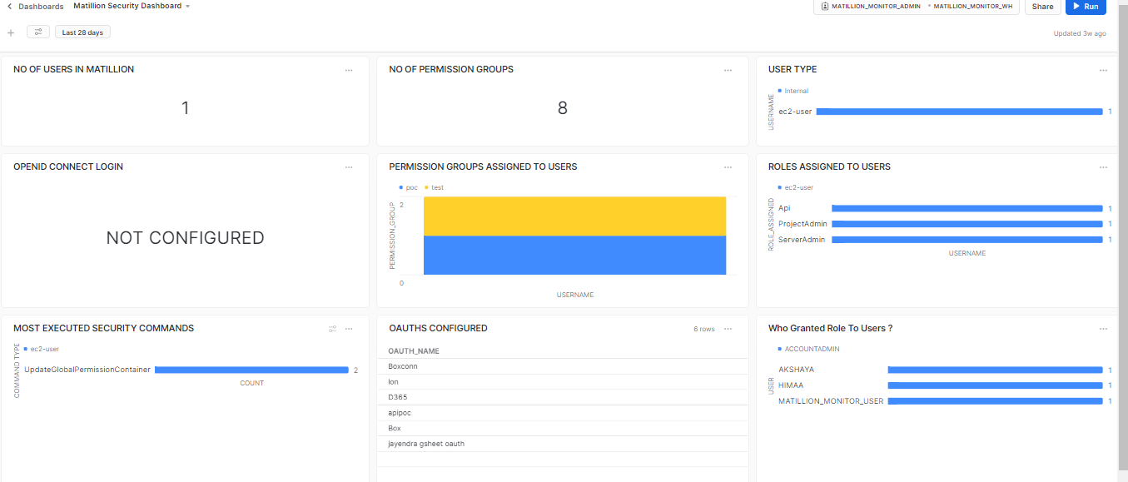

**1 NO OF USERS IN MATILLION:**

SELECT COUNT(*) FROM MATILLION_MONITOR_DB.MATILLION_MONITOR_SCHEMA.USERCONFIG;

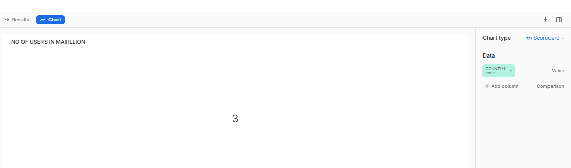

**2 NO OF PERMISSION GROUPS:**

SELECT * FROM MATILLION_MONITOR_DB.MATILLION_MONITOR_SCHEMA.PERMISSION_GROUPS;

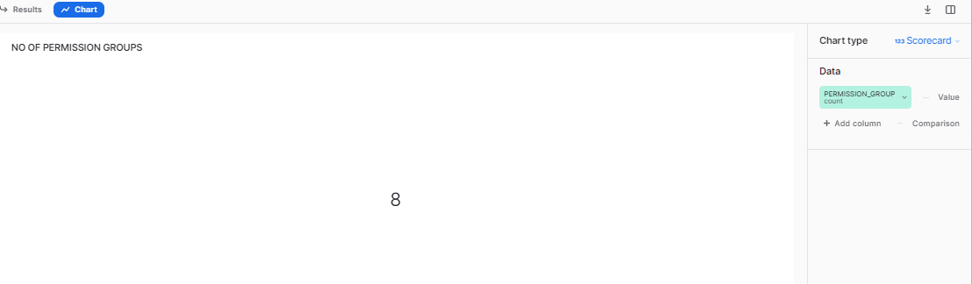

**3.3 USER TYPE:**

SELECT TYPE AS USER_TYPE,USERNAME FROM MATILLION_MONITOR_DB.MATILLION_MONITOR_SCHEMA.USERCONFIG;

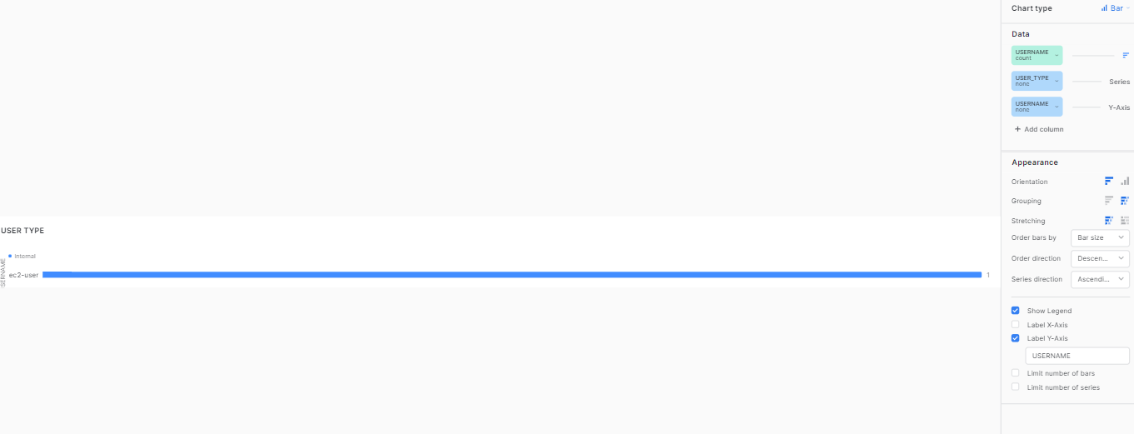

**4 OPENID CONNECT LOGIN:**

SELECT

case

when TYPE='Internal' AND ISOPENIDCONFIGURED ='FALSE' THEN 'NOT CONFIGURED'

WHEN TYPE='Internal' AND ISOPENIDCONFIGURED ='TRUE' THEN 'CONFIGRUED'

WHEN TYPE ='External' THEN 'NOT POSSIBLE FOR EXTERNAL USERS'

END AS "OPENID SETUP"

FROM MATILLION_MONITOR_DB.MATILLION_MONITOR_SCHEMA.USERCONFIG_1 LIMIT 1;

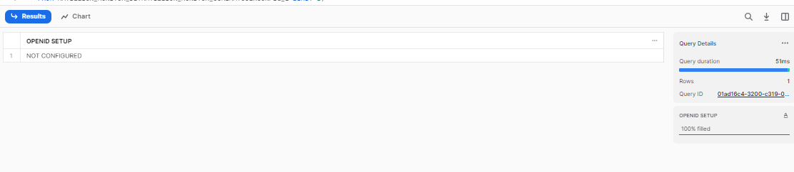

**5 PERMISSION GROUPS ASSIGNED TO USERS:**

SELECT * FROM MATILLION_MONITOR_DB.MATILLION_MONITOR_SCHEMA.USER_PERMISSION_GROUPS;

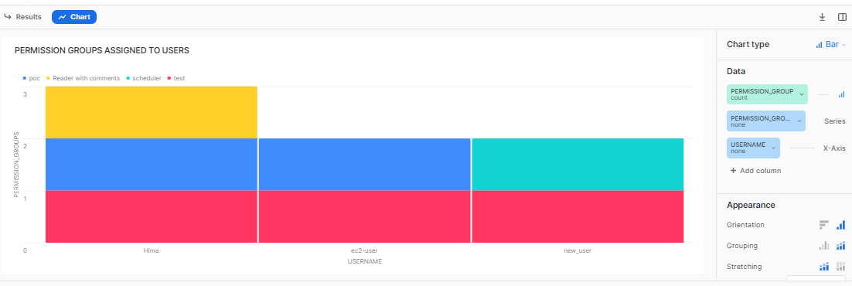

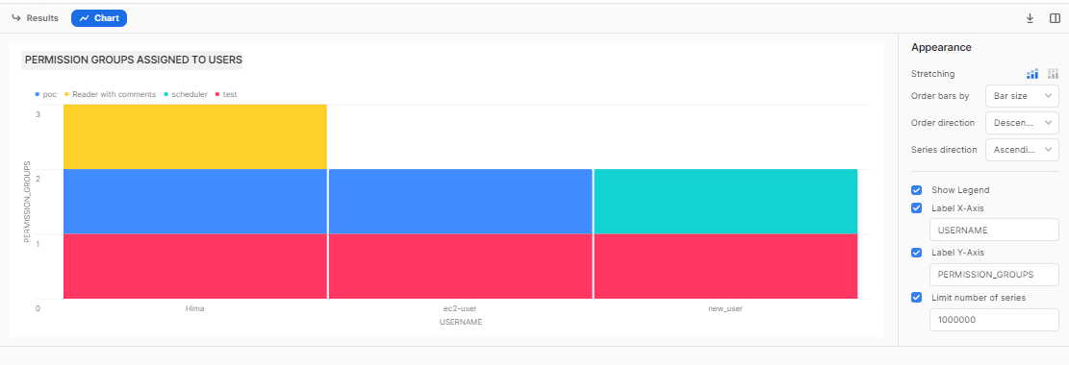

**6 ROLES ASSIGNED TO USERS:**

SELECT * FROM MATILLION_MONITOR_DB.MATILLION_MONITOR_SCHEMA.USERCONFIG_1;

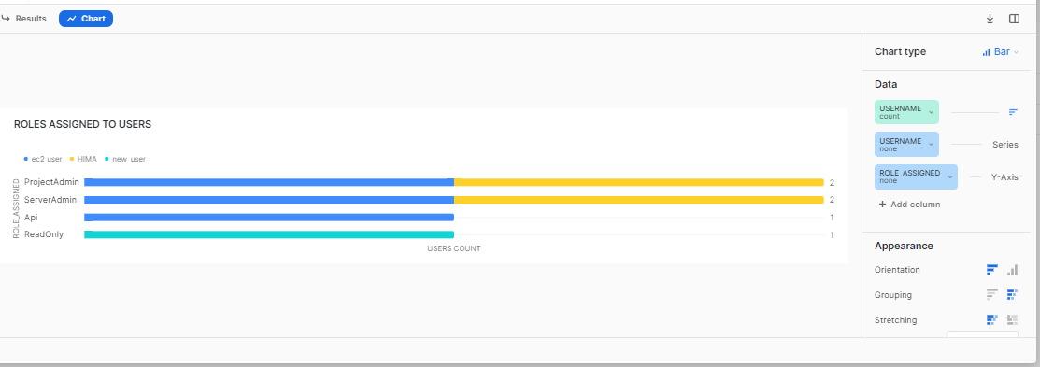

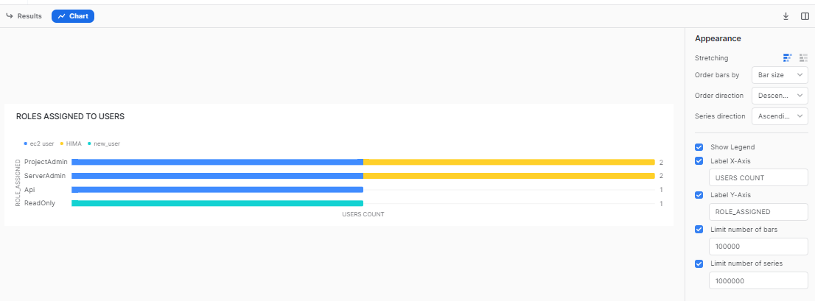

**7 MOST EXECUTED SECURITY COMMANDS:**

select * from MATILLION_MONITOR_DB.MATILLION_MONITOR_SCHEMA.AUDIT_NEW WHERE SPECIFIER LIKE '%Security%' and timestamp=:daterange;

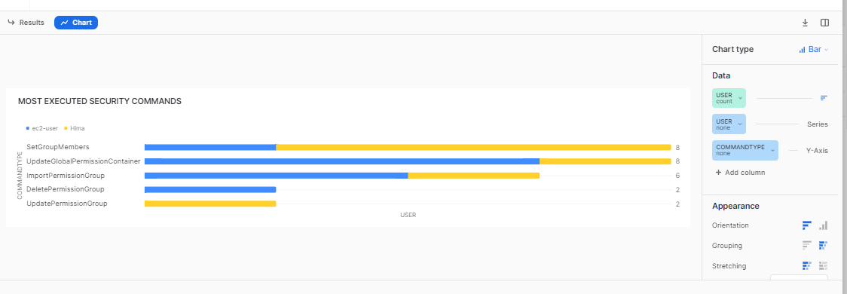

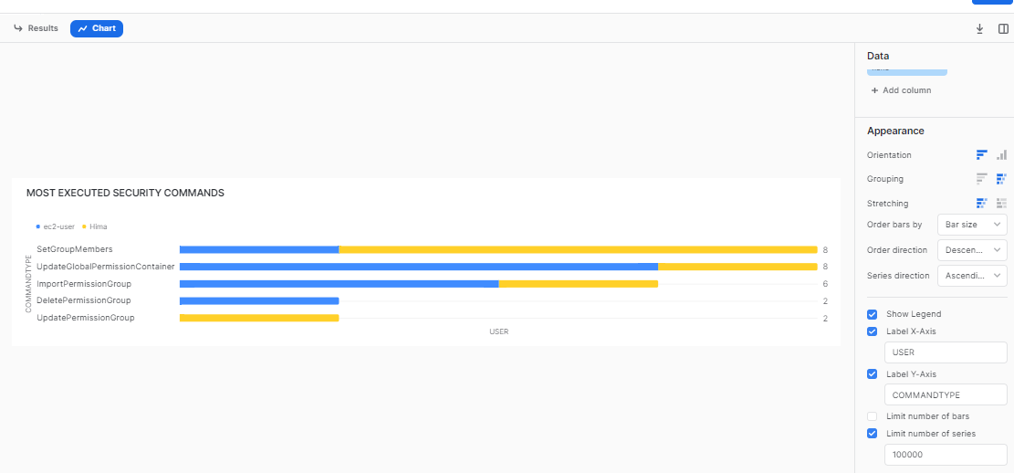

**8 OAUTHS CONFIGURED IN MATILLION:**

SELECT * FROM MATILLION_MONITOR_DB.MATILLION_MONITOR_SCHEMA.OAUTH;

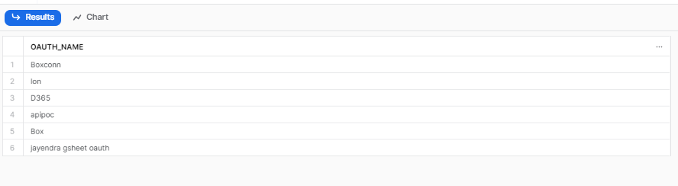

**9 Who Granted Role To Users ?:**

SELECT GRANTEE_NAME AS USER,

IFNULL( GRANTED_BY , 'NONE' ) AS GRANTED_BY,

CREATED_ON FROM SNOWFLAKE.ACCOUNT_USAGE.GRANTS_TO_USERS WHERE GRANTED_TO='USER'

AND

ROLE= CURRENT_ROLE() AND DELETED_ON IS NULL;

